Advanced Placement Micro/Macro Summer Assignment
Due: Tuesday September 8, 2015
Value: 100 points

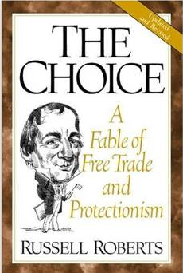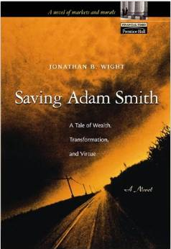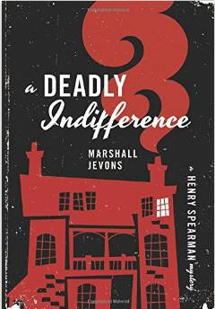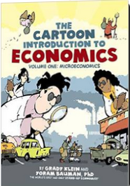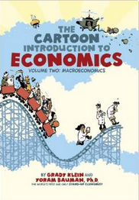

Read: Choose one of the books from the attached booklist to read. Each author has incorporated economic theory into a more untraditional setting of mysteries, romances and other fictional writing or cartoons. Summaries and reviews for each one are provided on the booklist.

Part A (worth 50 points): Pick out one economic theory that is used in your book and answer the following three questions below in paragraph form (5 sentence minimum). Cite any and all sources used.

- Find an economic theory or concept that is used within the story. Identify the page number where the idea is cited. Explain the setting or context that it was used in as well as what the theory says. Make sure that you include a graph or other visual that applies to the economic theory.(Graphs/charts are a huge part of the AP test)
- What economist is credited or commonly associated with this theory? Provide a brief synopsis of that economist and his work.
- Apply your understanding of this economic theory to a real scenario from the last decade.

Part B (worth 50 points): Teach the economic theory that you picked out from your book! Being able to teach others shows mastery of your understanding. Students who have the same theory in the same class may “team” teach.

- Teach the economic theory to the class in 10 minutes or less! Address the following within your lesson.
  - Decide what format works best for you. Examples include but are not limited to lecture, powerpoint, prezi, go animate, or video.
  - Include some kind of visual(s) that uses either graphs or charts to illustrate the concept.
  - Credit the economist(s) that this concept is usually connected to. Use a real life scenario to apply it to.
  - Include a connection of this concept to the present day.
  - Create a short quiz, activity, poll or other method to assess whether your audience understands the concept as taught.
- This will be graded according to the following rubric:
Criteria | 4 | 3 | 2 | 1
Organization | Student present information in logical, interesting sequence which audience can follow | Student presents information in logical sequence which audience can follow | Audience has difficulty following because presentation jumps around | Audience is confused because there is no clear sequence of information
Content Knowledge | Student demonstrates full knowledge (more than required) with explanations and elaborations | Student is at ease with content but fails to elaborate | Student is uncomfortable with information and is able to answer only rudimentary questions about subject | Student does not have grasp of information; student cannot answer questions about subject
Visuals/  Graphs | Student demonstrates full knowledge of the visual/graph with explanations and elaborations | Student is at ease with the explanation of the visual/graph | Student has appropriate visual or graph but can only answer rudimentary questions about it | Student does not show an understanding of visuals/graphs that explain/illustrate the concept; student cannot answer questions about it
Delivery | Student’s voice is enthusiastic, confident and pronounces terms correctly. Audience enjoys the sights and sounds of the presentation. | Student’s voice is clear. Student pronounces terms correctly. Audience can easily hear and see presentation | Student incorrectly pronounces terms. Audience members have difficulty hearing or seeing presentation | Student mumbles, incorrectly pronounces terms, speaks too quietly for students in the black of the class to hear, or cannot see the presentation
Evidence of Audience Understanding | Student has engaging tools to measure audience understanding | Student has basic measurement tool that accurately measures audience understanding | Student uses a very informal or minimal measurement tool of audience understanding | Student does not have any measurement tools of audience understanding

